Exercise 2

1. Refer to the CSV - HW2ExerciseSample1.

Insert the Data in the CSV file into a table in the Database

* Table Name – User Details
* Use Import Wizard to Create table and Copy Data

Output:

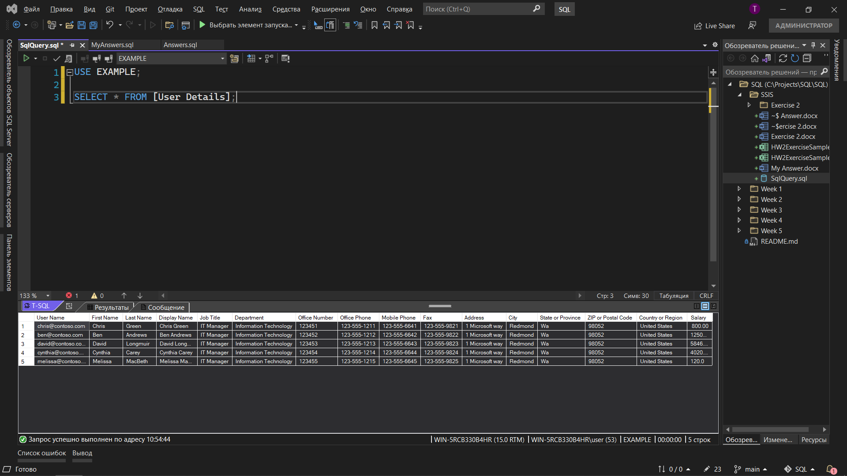

The remaining exercises are in SqlQuery;